Boston University
Mechanical Engineering Department

ME 419 HEAT TRANSFER

TRANSIENT HEAT CONDUCTION AND
CONVECTION LABORATORY

(Experiment developed by Prof. D. Wroblewski, Prof. M. Isaacson, and G. Dewar, 1999; Revised by D. Kelly, M. Raymond, M. Dvilyanskiy, 2002; B. Vattiat, J. Estano, D. Campbell, 2005; D. Karabacak, 2007; B. Nagpure and Prof. M. Isaacson, 2009)

- Introduction

A common engineering problem involves predicting or modeling the temperature of a solid body when that body is exposed to a sudden change in its thermal environment. Take for example a quenching operation, where a metallic part at elevated temperature is placed into an oil or salt bath to achieve a desired metallurgical state. The part’s final microstructure is a result of the internal stresses which arise due to thermal gradients during quenching. Therefore, it is helpful to know how the thermal gradients will arise in that part and what parameters of the part design affect the desired performance characteristics.

One simple method for predicting the temperature within a solid during such a transition is the “lumped capacitance method”. This method makes the assumption that the spatial thermal gradients within the solid are negligible; or the temperature is uniform throughout the solid. However, in some cases the assumption of uniform temperature is incorrect and using lumped capacitance method provides false results. More complex models which account for the spatial variation of temperature within the solid must be used. Often, the first step an engineer must make when solving a transient heat transfer problem is to determine which method is most suitable. This is done using the Biot number.

The Biot number is a comparison of two thermal resistances: the thermal resistance associated with conduction of heat within the solid of interest, and the thermal resistance associated with convection of heat into or out of that solid.

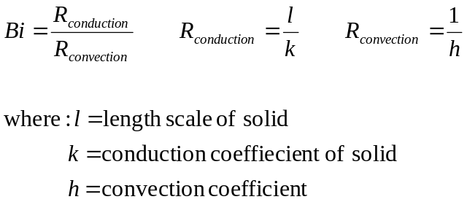

In cases where the conduction resistance is very small compared to the convection resistance (Bi << 1), the temperature can be considered uniform throughout the solid. This is because the thermal energy that enters the surface of the solid through convection will be quickly conducted to the rest of the solid. However, when the conduction resistance is not small compared to the convection resistance (Bi ~ 1 or Bi > 1), thermal energy will build up near the surface and result in a non-uniform temperature within the solid.

This laboratory experiment demonstrates two transient thermal responses: one where Bi << 1, and one where Bi > 1. The estimates of the thermal response for each case will be produced using two methods and compared to the measured data.

2. Laboratory Information / Description of Experiment

The goal of the experiment is to measure the transient thermal response of a sphere when moved from a hot water bath to a cold water bath, and vice-versa. To illustrate two regimes of transient thermal response, two spheres are used: one made of copper (high thermal conductivity) and one made of stainless steel (low thermal conductivity).

Both spheres are identical in construction:
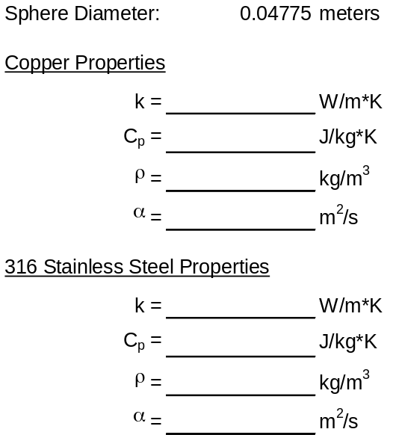
Handle
Copper/Steel Sphere
Thermocouple 1
Thermocouple 2
(see note on thermocouples)

Each sphere is equipped with two thermocouples. The junction of one thermocouple is at the center of sphere, and the junction of the second thermocouple is located about 2mm from the surface of the sphere. The temperature signals from the thermocouples will go through a signal conditioning system and recorded on the computer using a data acquisition system and National Instruments LabView software. The operation of the thermocouples and signal conditioning system are explained in the section Note on Thermocouples.

3. Theory of Experiment

Two cases, or “regimes”, of transient conduction are being evaluated. The lumped capacitance method is used for cases where the Biot number is small (Bi << 1). The lumped capacitance method models the solid as a thermal energy storage element, analogous to a capacitor holding electric energy in an electric circuit. The thermal energy of the solid can drain into the environment, but must travel through the thermal resistance associated with convection. The result is an exponential decay in temperature. The derivation of this is available in the class text, with the generalized equation found below:

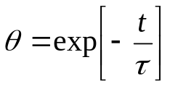

For this problem, θ is the normalized temperature difference. Like almost every other exponential decay problem encountered in engineering, the solution is characterized by it’s time constant. For this problem, the time constant is a product of the solid’s thermal capacitance and the resistance of convection:

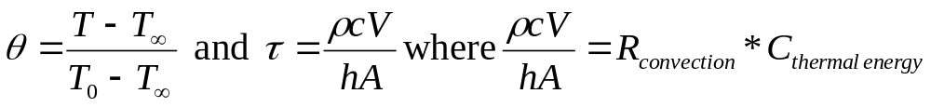

For cases where the thermal resistance of conduction is not small compared to the thermal resistance of convection, (Bi ~ 1) thermal energy will not be uniformly distributed throughout the solid. The temperature within the solid will be dependent on position in the solid and time. For the case of a sphere, the temperature is dependent on the distance from the center (r) and time. The solution is found by solving the differential equation:
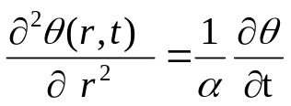
and applying the following boundary equations:

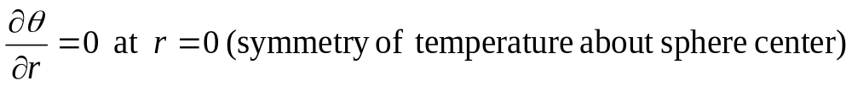
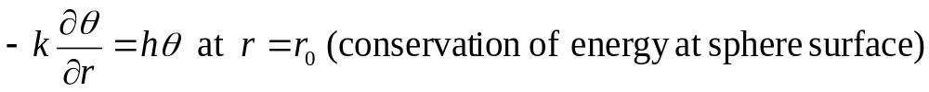

and the initial condition:

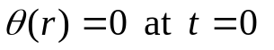

The derivation of the result is beyond the scope of this lab, but can be found in various texts. The final result is presented below:

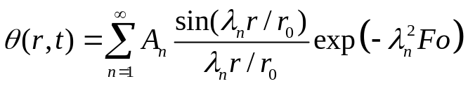
where Fo represents the Fourier number:
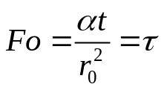
The Fourier number is a comparison of the time of interest, t, to the diffusion time related to the solid of interest. This is an important number because for the solution presented above is not valid for 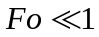.

The coefficient A_{n} is a result of the solution being expressed as the superposition of an infinite series.
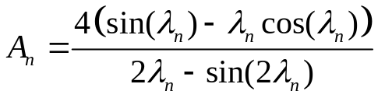

The characteristic values 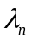 are the roots of the equation:
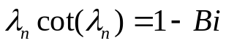
For this experiment, the level of precision desired requires only that the first two roots be used. Values for A_{n} and for n = 1 are tabulated below as a function of the Biot number.

Usually, we are interested in the solution for times with Fo >0.2, and thus the solution to our original differential equation could be approximated using the one-term approximation; for the sphere it is given as

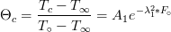 (1st order approximate equation)

Therefore, using the experimental value of λ₁ and the table below, Biot number could be obtained for the sphere. Note: for our purposes, A₁ is not used in predicting Biot number as Biot number is more closely related to λ₁ than A_{1.}
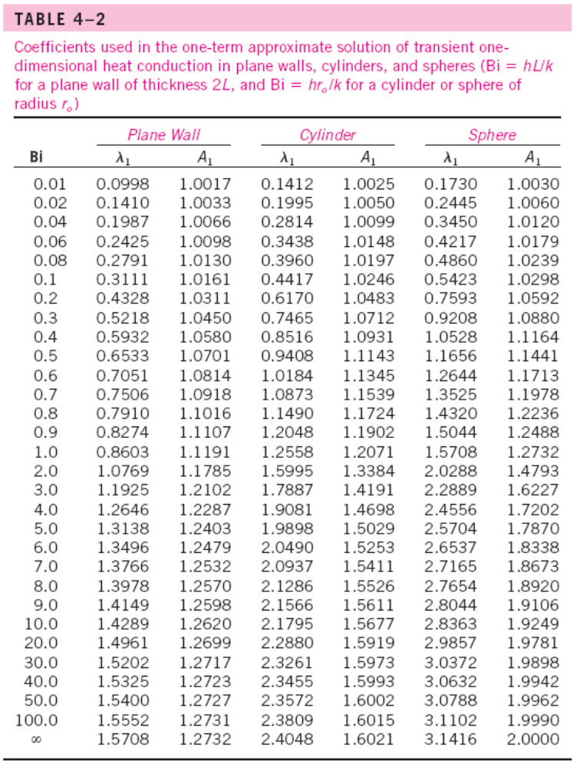
*adapted from "Heat and MassTransfer", Y. A. Çengel, 2007, McGraw-Hill
Comparing the use of Lumped Capacitance Method in copper and stainless steel

In our case, we have non-dimensional temperatures at the center and surface of the sphere, respectively, given by
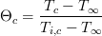

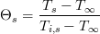

where the initial temperatures are T_{i,s} = T_{i,c} = T_{0.}

Therefore,
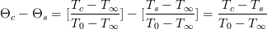
T
r₀
T_{c}
T_{s}
T_{c} - T∞
T∞
T_{s} - T∞
T∞

r

Lumped capacitance method helps us predict the temperature within a solid during a transition. This method assumes that the thermal gradient, temperature change, inside the solid is very small compared to the thermal gradient, temperature change, outside the solid (or from the center of the solid to infinity, since most of the change is outside the solid). Therefore, the use of this method to predict the temperature within a solid is only valid if

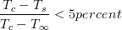

i.e. the temperature drop inside the solid is less than about 5% of the total temperature drop.

Non-dimensionally, we can express this “Internal Temperature Difference Ratio” (ITDR) criterion as:

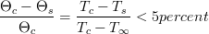

4. Laboratory Procedure

The experiment will consist of eight (8) trials, where each trial will measure the temperature within a sphere moving from one bath to another.

Trial | Sphere | Transition
1 | Copper | Cold to Hot
2 | Copper | Hot to Cold
3 | Copper | Cold to Hot
4 | Copper | Hot to Cold
5 | Stainless Steel | Cold to Hot
6 | Stainless Steel | Hot to Cold
7 | Stainless Steel | Cold to Hot
8 | Stainless Steel | Hot to Cold

4.1 Setup

- Two water baths of equal size and volume should already be filled and preheated to 30ºC and 60ºC upon arriving at the lab. Verify their temperature with a liquid-in-glass thermometer.
- Assemble the thermocouple measurement system according to Appendix A.
- Start the AM419TransientThermal LabView program if it is not already running.

4.2 Trial Procedure

Important note: This lab compares the thermal response of two spheres of different thermal conductivity, but same convection coefficient. It is therefore essential that the sphere is held still and in the same position for each trial. Use the aluminum fixtures to maintain the sphere in a consistent position near the circulator nozzle.

- Place the copper sphere in the cold water bath and wait for its temperature to reach steady state.
- Enter the trial number in the “Trial Number” field of the AM419TransientThermal program.
- Press the “RECORD” button on the program.
- After about 5 seconds, transfer the sphere from the cold bath to the hot bath. Try to move the sphere to the hot bath as quickly as possible. At the same instant the sphere enters the hot bath; press the “MARK ZERO TIME” button.
- When the sphere temperature reaches steady state, press the “EXIT” button.

Repeat the procedure for the remaining trials.

5. Calculations and Analysis

The procedure of converting raw data to useful engineering information is critical to the success of this and any experiment, so it is suggested that you carefully layout your spreadsheet or math analysis environment in a organized and logical manner.

5.1 For each trial, the voltage recorded from the instruments was converted to the corresponding temperature by the data acquisition software using the proper calibration for the thermocouples.
- plot the temperature recorded at the center and surface of the sphere as a function of time for each of the 4 trials.
- Identify three sections of each series: an initial flat part (data from before sphere was moved), a sloping or transient part, and a final flat part. The flat section at the beginning and end of each series corresponds to when the sphere was at a steady temperature
- From the flat part at the beginning of the series (before sphere was moved), compute and average initial temperature, T₀. Averaging is done to reduce the effect of signal noise
- from the flat part at the end of the series, compute and average final temperature, T∞
- compute θ for every point in the series

5.2 Plot θ _{c} and θ_{s} as functions of time. Each series should look like an exponential starting at 1 and decreasing to 0. If this is not the case, go back and check your previous calculations.

5.3 Next, determine the exponential constant for each series using a linear curve fit on a semi-log plot.
- Compute and plot ln (θ_{c}) against the Time data
- Calculate least squares linear curve-fit (“trend line”) to ln(θ_{c}) ‘vs’ Time data (Note: only use the experimental data for Fo>0.2. This should give a linear fit on the semi-log plot. This translates to using only data after 2 seconds for Copper and after 28 seconds for Stainless Steel. Also, do not include the data for very long times when the points are jumping all around, since the signal differences are so small at these long times that digital conversion error is interfering with the data.)
- By comparison of curve-fit equation that you just found, with the 1st Order Approximation Equation (page 4), estimate values for λ₁ as shown below:

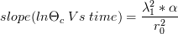

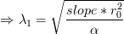

- Using the estimated value of λ₁, find Bi from Table 4-2 in Çengel. Use this to calculate ‘h’ for the experiment. Use the relation Bi = h r_{o} /k.
The value of ‘h’ found here is valid regardless of whether or not the system behaves as a lumped capacitance.
- Now assuming the case is Lumped Capacitance so that

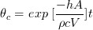

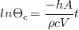

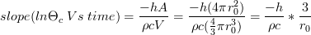

again for t such that F>0.2, calculate h as shown

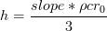

Here “slope” is the slope of the trend line found from the curve fit in the second bullet.
- Compare h from 1st term approximation (fourth bullet, above) to h from Lumped Capacitance analysis (fifth bullet, above).
- Plot θ_{c}, θ_{s}, and the internal temperature difference ratio ITDR ={(θ_{c} - θ_{s} )/ θ_{c} }as functions of time on the same graph.
- From your plot, determine the maximum value for the internal temperature difference ratio (ITDR)_{max} for F₀>0.2 (i.e. t >2s for Cu and t >28s for stainless steel).
- Discuss your results for all cases. For each case compare the value of h found from the λ₁ table with the value found from assuming lumped capacitance, and comment on the validity of the lumped capacitance assumption in light of the value of Bi from the λ₁ table and the value you determined for (ITDR)_{max}. If lumped capacitance is valid, ((ITDR)_{max} should be small and the ‘h’ value determined from both methods should be close to each other.

Appendix A: Thermocouple measurement system setup

The signals from the thermocouples are sent to an artificial ice point/ lineariser (which converts the thermocouple reading into a temperature in degrees C), then sent through a D.C signal amplifier and the signals are finally captured by an A to D board (Analog to Digital Converter) installed in a PC. This signal can then be analyzed and stored (using a LabView program) for later use (see Figure 2).

Artificial Ice Point/
Lineariser D.C Amp A to D Board PC with LabView

Thermocouple 1

Thermocouple 2

Figure 2.

The two water baths are held at 60ºC and 30ºC respectively using immersion circulators. The experiments involve holding the sphere in one of the baths until the sphere has time to reach a steady state temperature, and then quickly moving the sphere into the other bath while starting the LabView program. Use the aluminum jig on the top of the bath to consistently locate the sphere through each trial. Experiments will be carried out placing the sphere at the exit nozzle of the circulator jet (high convection conditions) and in the center of the bath (low convection conditions).
The LabView program in the PC records the temperature readings from both the center and surface thermocouples and sends them to a spreadsheet file (from which the data can be analyzed). The program allows control of the number of temperature readings to be taken per experiment and the rate at which these measurements are taken (in readings per second).

Note: The circuits in the room are numbered. To reduce noise, plug the immersion circulators into a different circuit then the Artificial Ice Points.

Appendix B: Note on thermocouple measurement

Temperature measurement using thermocouples relies on the Seebeck Effect, where an electronic potential difference exists at the junction of dissimilar metals. The magnitude of the electronic potential is a function of temperature; therefore the voltage measured across the junction of two metals is correlated to the temperature of that junction.
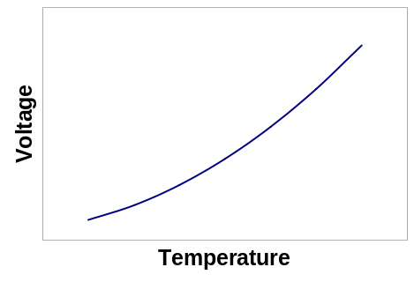
Constantan wire
Copper wire
+
-
V
T
The particular relationship between voltage and temperature is unique to the combination of metals used in the thermocouple. Two metals are usually chosen for the temperature range anticipated and several common combinations are denoted by a letter. The copper-constantan combination used in this experiment is Type T.

Whatever the combination of metals used in a thermocouple is, the voltage measured is usually only a couple millivolts. Since such a small voltage is difficult to measure in practice, an amplifier is usually necessary.
Another complication to implementing thermocouples is due to the fact that simply measuring the voltage of a thermocouple creates a second thermocouple junction. Consider using a standard digital voltmeter to measure the voltage of a thermocouple: the digital voltmeter probe is probably copper itself. Therefore, the voltmeter probe touching the constantan wire of the thermocouple creates a small voltage which is in series with the thermocouple junction you want to measure. The result is a measurement of the temperature at the thermocouple, minus the temperature at the voltmeter leads.
Constantan wire
Copper wire
+
-
V(T_{thermocouple})
V(T_{voltmeter})
V_{measured}
+
-
-
+
V_{measured} = V_{thermocouple} - V_{voltmeter}
T_{measured} = T_{thermocouple} - T_{voltmeter}
T_{voltmeter} = ???
Therefore, in order to make an accurate thermocouple temperature measurement, the temperature at the voltage “probe” must be known. The simplest way to do this is by fixing the temperature of the voltmeter probe to a known, constant value. Traditionally, an ice bath was used and termed the ice-point. Another way is to measure the temperature of the voltmeter “probe” with another temperature measurement device. Modern artificial ice-points use some semiconductor-based device (thermistor) to measure the temperature at the thermocouple-voltmeter junction.

The final challenge to making temperature measurements is converting the voltage measured at the thermocouple to units of temperature. Since the relationship between temperature and voltage is non-linear, it is convenient to use an electronic linearizer to convert the signal to a known, linear proportional signal.
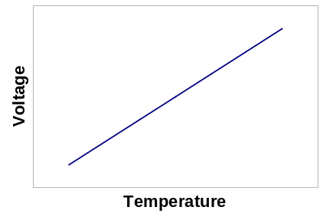
Linearizer
The problem of measuring temperature as a function of time also requires the ability to record the temperature measurements quickly. Computer-based data acquisition hardware can quickly convert such voltage signals to digital records and store them for further analysis.

Sphere Diameter: | 0.04775 | meters
Copper Properties
k = |  | W/m*K
C_{p} = |  | J/kg*K
ρ = |  | kg/m³
α = |  | m²/s
316 Stainless Steel Properties
k = |  | W/m*K
C_{p} = |  | J/kg*K
ρ = |  | kg/m³
α = |  | m²/s

